Name : Saurabh Sanjay Jadhav

Topic : Amazon Cloudwatch & event bridge.

Assignment no. : 24

1. Create an EC2 instance for checking cloudwatch working.

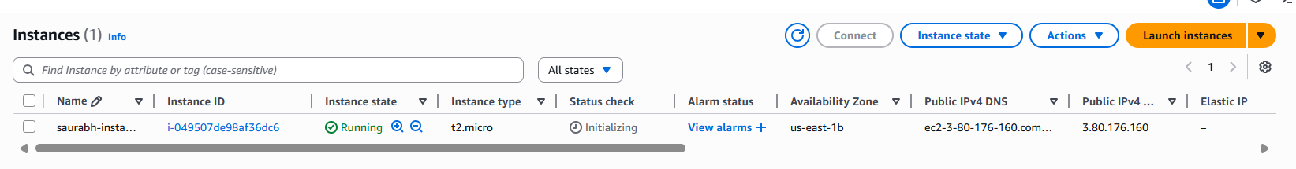

1. Create a dashboard to view the performance of saurabh-instance.
2. Name the dashboard “ec2-instance-dashboard”.

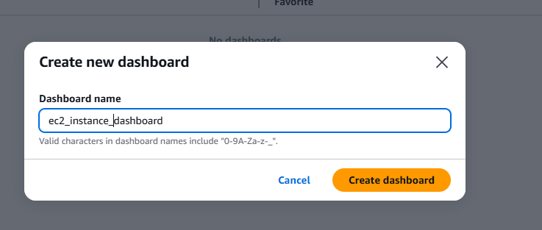

1. Select the widget type as “Bar”.

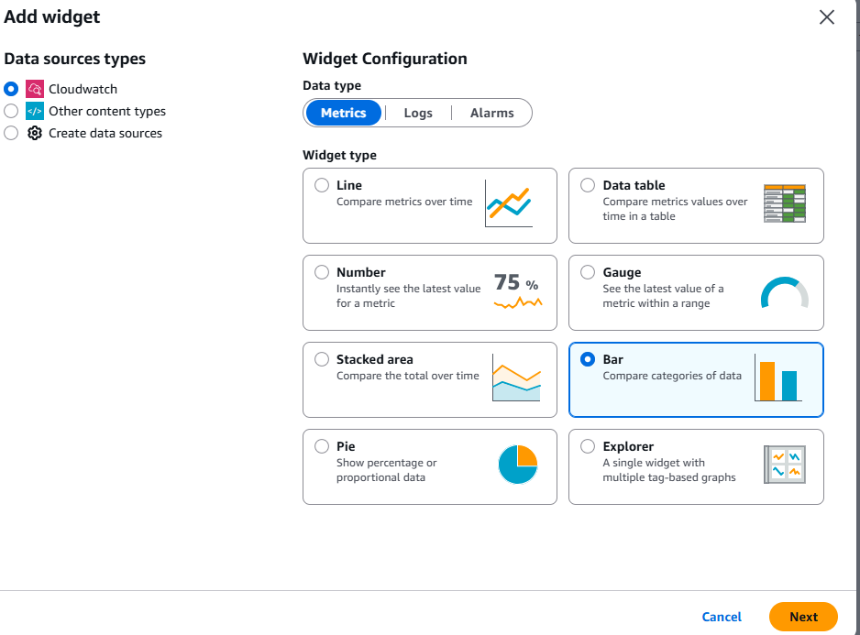

1. Select the metrics to show on bar chart.

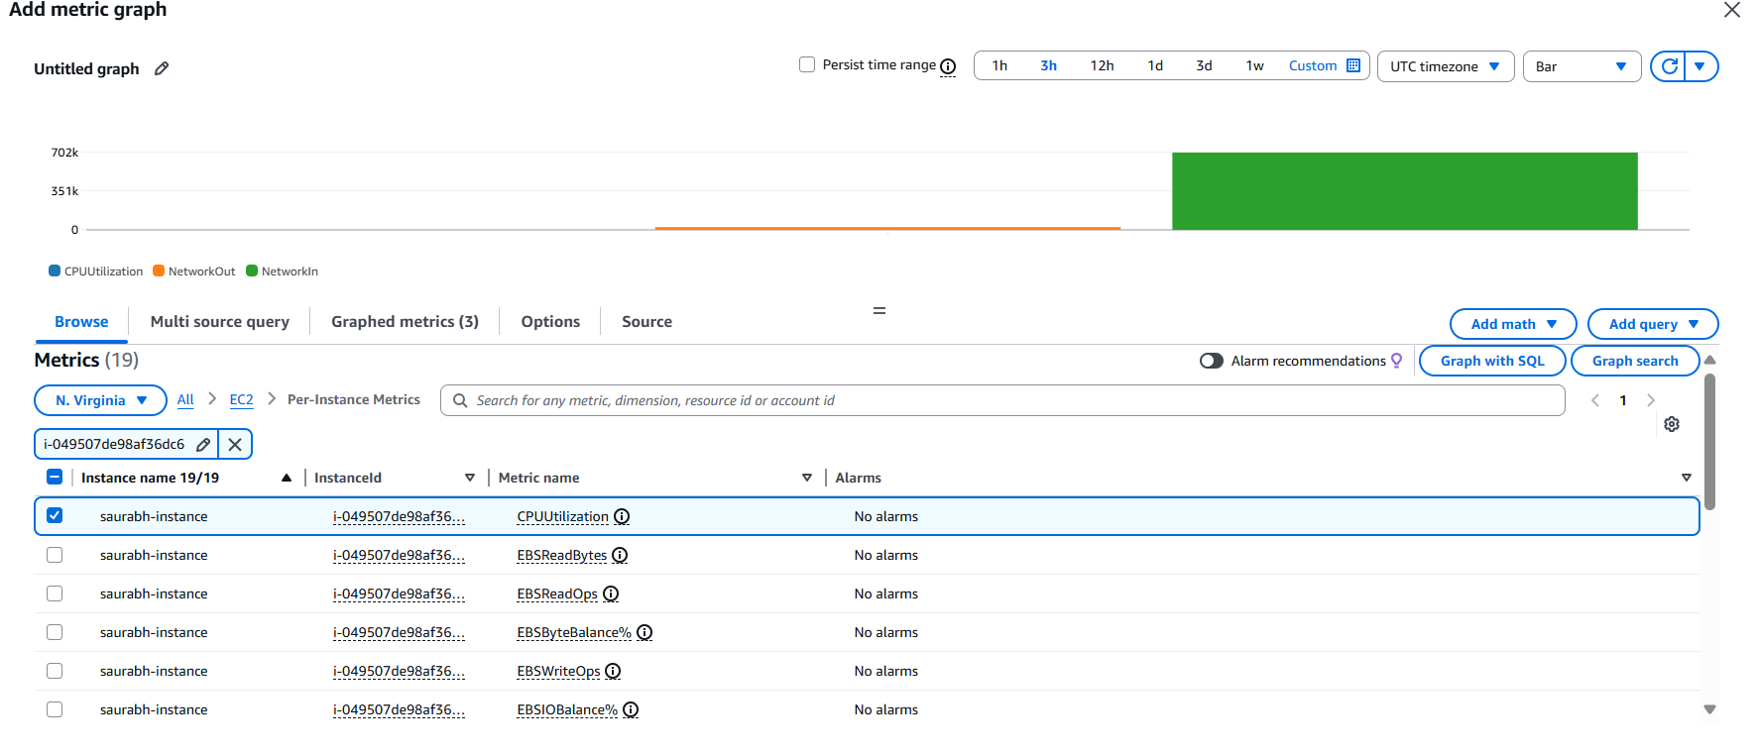

1. Connect to EC2 instance and run some commands to show CPU utilization, transfer of network packets.

1. Create another widget in dashboard.

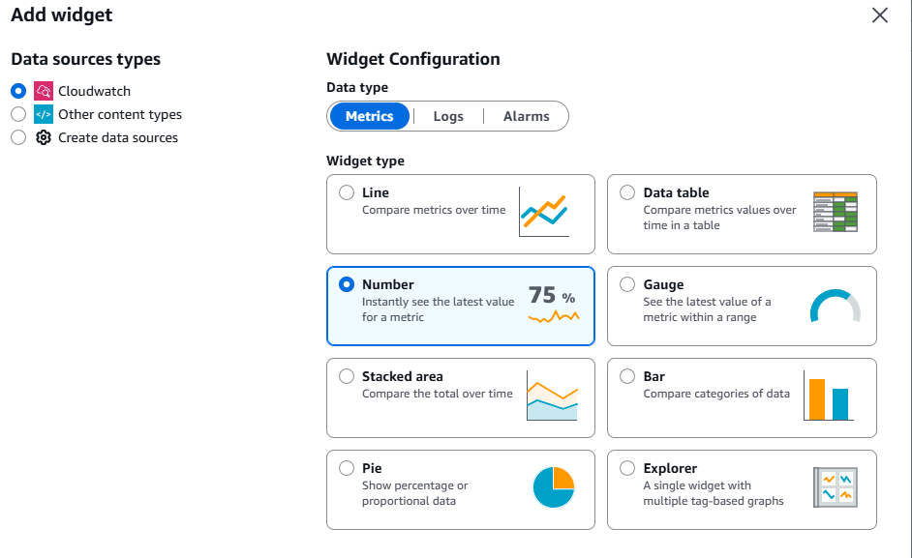

1. Check the details of metrics.

1. Create SNS service.
2. Create a topic.

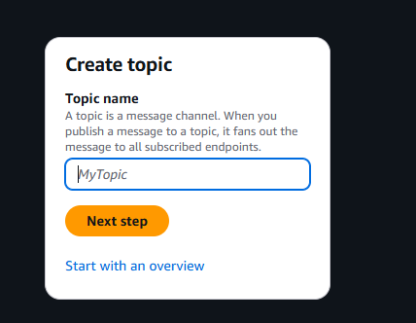

Select the type of topic.

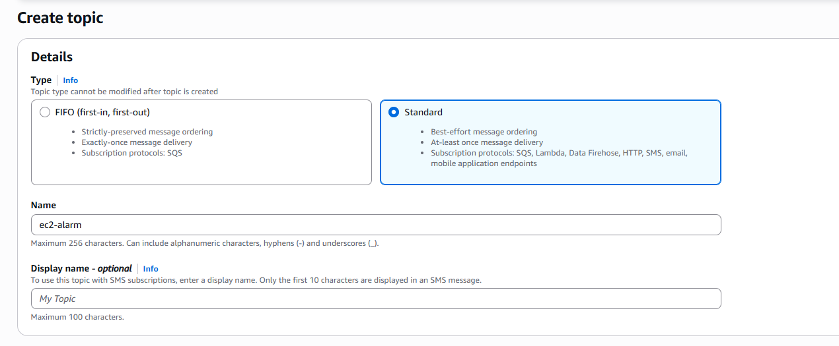

1. Create subscription.

Protocol : email, endpoint: [saurabhsj2711@gmail.com](mailto:saurabhsj2711@gmail.com)

Mail will be sent for confirmation.

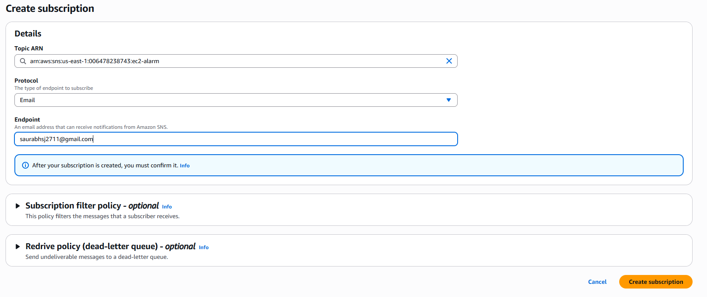

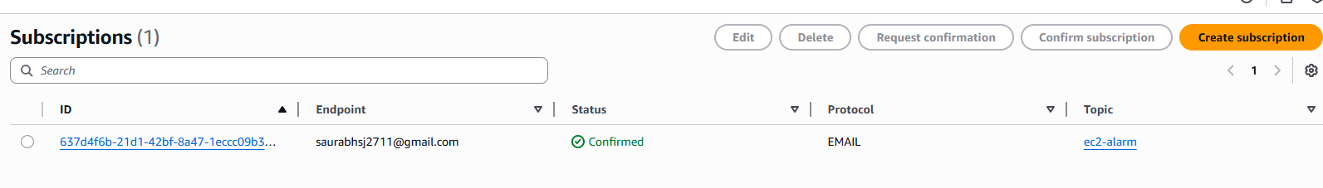

1. Create Alarm for conditions of metric performance.
2. Select the metric.

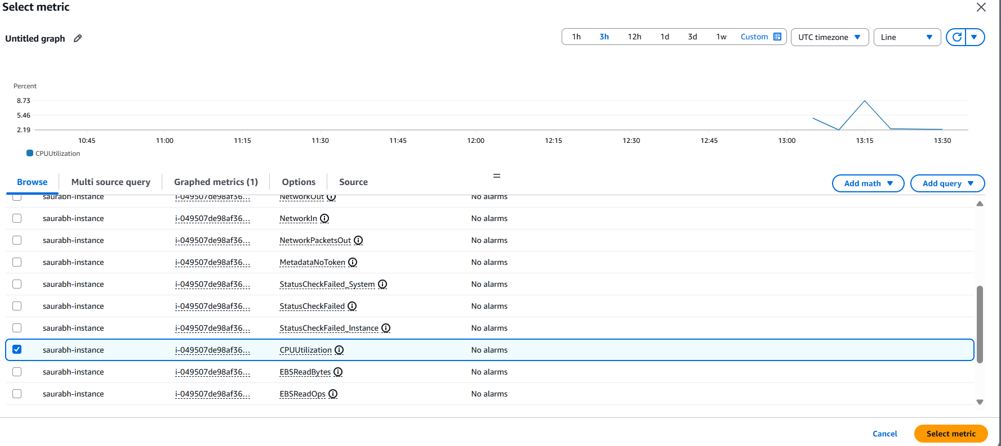

1. Provide the condition for metric.

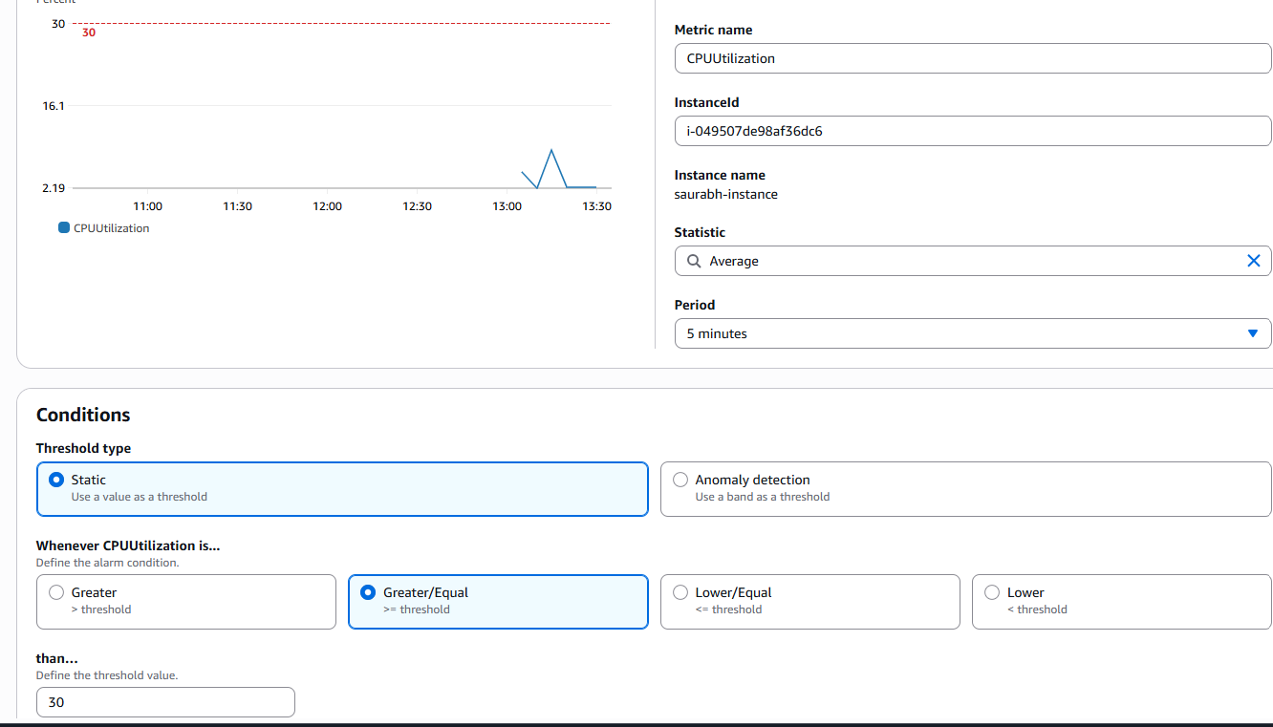

1. Configure the action to be taken if metrics limit condition is crossed.

Select the SNS topic .

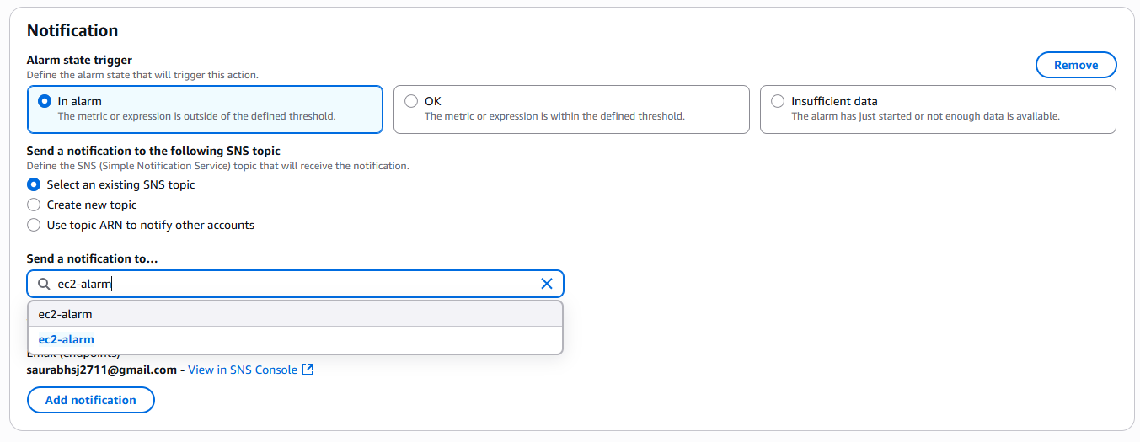

1. Provide name to alarm.

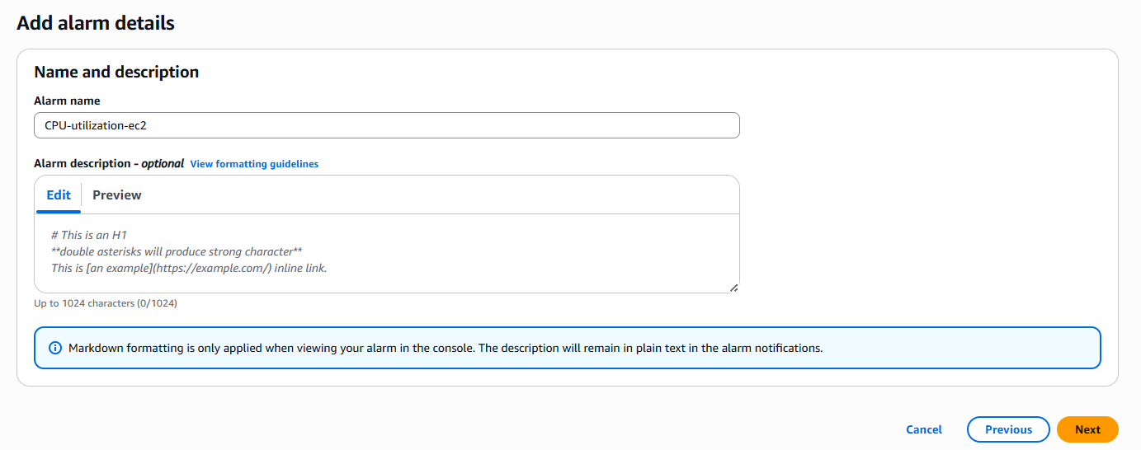

1. Alarm created.

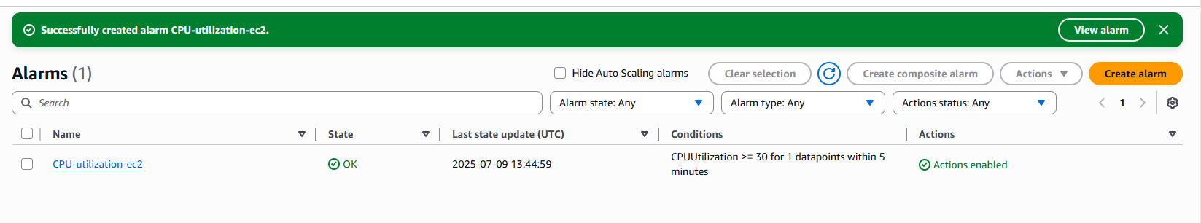

1. Create Amazon event bridge.

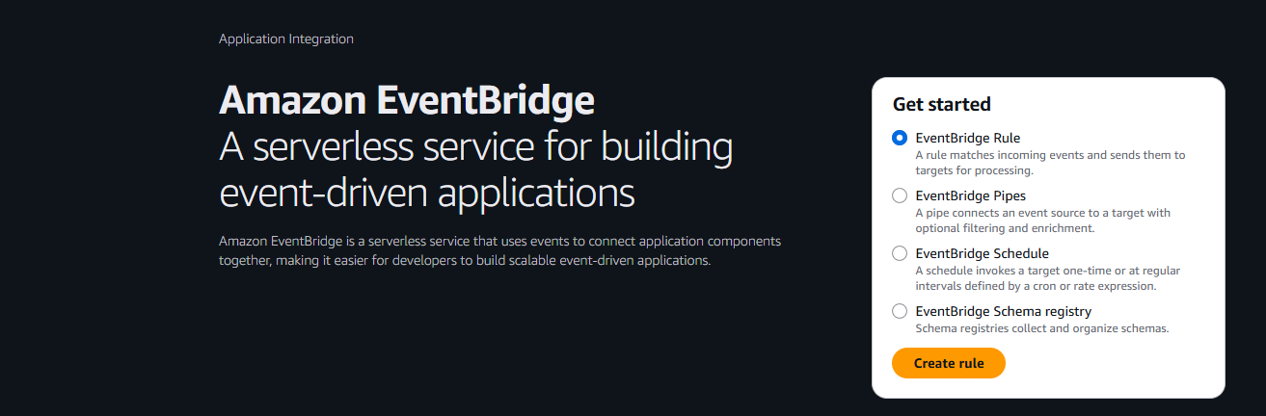

1. Provide name to rule,event bus, and rule type.

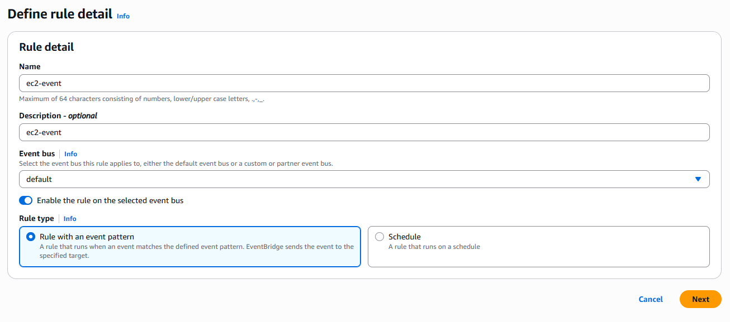

1. Provide event pattern.

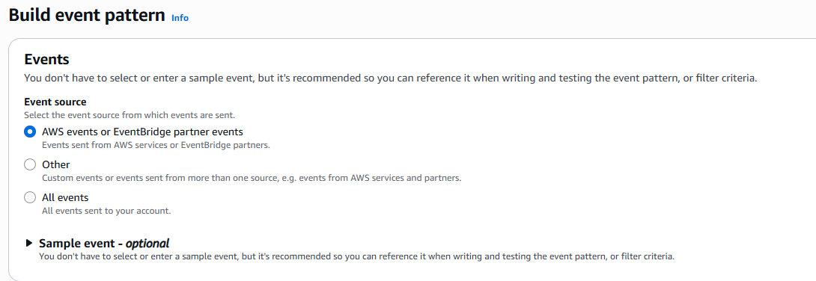

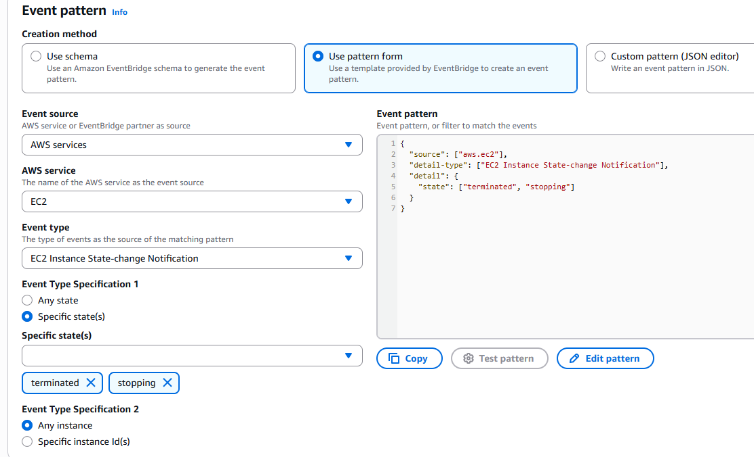

1. Select the action that should be taken if event takes place.

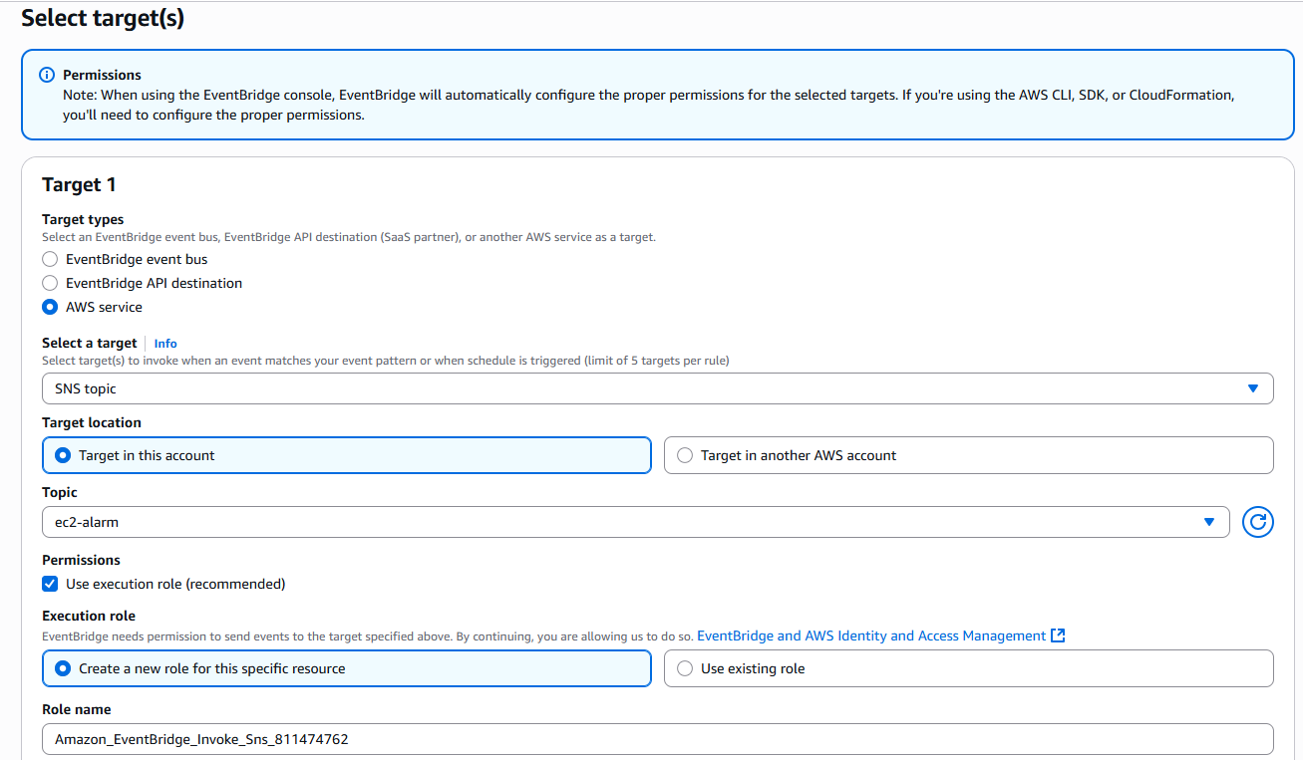

1. Successfully received the notification for EC2 instance termination.

